SPH3U ***Activity 1a: Can you Catch it? Reaction Time Investigation* Name: ____________**

**Activity Objectives:**

***1. To investigate the variability in reaction time for a given individual and between different individuals.***

***2. To investigate error or uncertainty in measurements and how to express measurements to the correct accuracy and precision.***

**Materials:** Desk, ruler or metre stick

**Procedure:**

1. Work in pairs. One person is the “catcher” and the other person in is the “dropper”.

2. The catcher rests their hand on the edge of the desk.

3. The dropper holds the ruler vertically above the partner’s hand with the “0” of the stick just above

their thumb and forefinger. The catcher should not be touching the ruler.

4. The catcher should close their eyes. The dropper will say “Go” and will release the ruler.

5. The catcher should catch the ruler as quickly as they can.

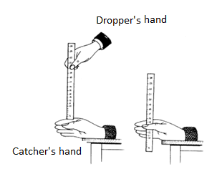6. Measure the distance the metre stick dropped by recording the measurement on the metre stick that is just above where the catcher gripped the stick.

7. Repeat TEN times for the same catcher and dropper.

8. Switch roles.

9. Find the average “dropping distance” for each person.

**\*Measure distances to the nearest millimetre.**

**(e.g 5.2 cm, 11.7 cm etc.)**

**Observation Table***: * Include units in your measurements!*

|  |  |  |  |  |  |  |  |  |  |  |  |  |  |  |
| --- | --- | --- | --- | --- | --- | --- | --- | --- | --- | --- | --- | --- | --- | --- |
| Trial # | 1 | 2 | 3 | 4 | 5 | 6 | 7 | 8 | 9 | 10 | Average Value | Lowest Value | Highest Value | Estimated Uncertainty $$\frac{Highest-Lowest}{2}$$ |
| Catcher 1 |  |  |  |  |  |  |  |  |  |  |  |  |  |  |
| Catcher 2 |  |  |  |  |  |  |  |  |  |  |  |  |  |  |

**Discussion Questions:**

1. How consistent was one person in their reaction times? Refer to your data to support your answer.
2. How does dropping distance relate to reaction time?
3. a) Who had the lowest average reaction time? Who had the highest average reaction time?

b) Use the Reaction Time Table to find the average reaction time for each member. List their times below.

Catcher 1: Name: ________________ Reaction time:____________________

Catcher 2: Name: ________________ Reaction time:____________________

1. Why is it best to repeat a measurement several times and find the AVERAGE value?
2. If a student had a dropping distance average value of 6.5 cm ± 0.2 cm, what would be the RANGE of dropping distance readings that they had ? (State the lowest and highest value).

**Activity 1b: Can you Swing it? Oscillation Time Measurement**

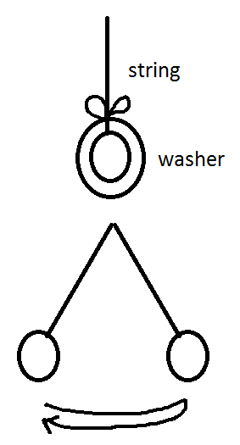

**Materials**: washer, string, stopwatch or stopwatch app on Smartphone

**Procedure**: 1. Tie the string to the washer to create a pendulum.

2. Partner 1 will hold the end of the string so that the washer

can be displaced to the side and released like a pendulum.

3. Once the pendulum is swinging, partner 2 will measure the time for

10 full swings of the washer (from one side to the next). Remember

to start the count with “zero” when you start the stopwatch and

stop the stopwatch when you count “ten”.

4. Find the average time for the 10 swings.

5. Repeat the experiment two more times.

6. Switch roles and repeat steps 2-5.

**Observation Table:** *\* Make sure to record all digits on the stopwatch display*

|  |  |  |  |  |  |  |  |
| --- | --- | --- | --- | --- | --- | --- | --- |
| Trial # | Trial 1  Time for 10 cycles (s) | Trial 2  Time for 10 cycles (s) | Trial 3  Time for 10 cycles (s) | Average Time  (s) | Lowest time  (s) | Highest time  (s) | Estimated Uncertainty $$\frac{Highest-Lowest}{2}$$ |
| Timer 1 |  |  |  |  |  |  |  |
| Timer 2 |  |  |  |  |  |  |  |

**Discussion Questions:**

1. What is the *precision* of the time values recorded by the stopwatch?
2. Looking at the estimated uncertainties in your data chart, is it possible to measure time to the precision of the stopwatch? Please explain.
3. What do you feel would be an appropriate UNCERTAINTY ESTIMATE or ERROR for most time measurement tasks?